***Dt : 25/11/2022***

***Sorting Process:***

***=>The process of organizing elements in Ascending order or Descending order is***

***known as Sorting process.***

***=>we use "sort()" method from 'java.util.Arrays class' to perform sorting process***

***on Array-Objects.***

***=>we use "sort()" method from 'java.util.Collections' class to perform Sorting***

***process on List-Objects.***

***=>we have "TreeSet<E>" to sort elements in Set<E> objects.***

***=>we have "TreeMap<K,V>" to sort elements in Map<K,V> objects.***

***=>we must not perform sorting process on Queue<E> objects because elements are***

***organized based on algorithm "First-In-First-Out".***

***Ex-program1 : Sorting process of Array objects.***

***Product.java***

***package test;***

***@SuppressWarnings("rawtypes")***

***public class Product extends Object implements Comparable***

***{***

***public int code;***

***public String name;***

***public Product(int code,String name) {***

***this.code=code;***

***this.name=name;***

***}***

***@Override***

***public String toString() {***

***return code+"\t"+name;***

***}***

***@Override***

***public int compareTo(Object o) {***

***Product p = (Product)o;***

***if(code==p.code) return 0;***

***else if(code>p.code) return 1;***

***else return -1;***

***}***

***}***

***ArraySort.java(MainClass)***

***package maccess;***

***import java.util.*;***

***import test.*;***

***public class ArraySort {***

***@SuppressWarnings("removal")***

***public static void main(String[] args) {***

***Integer a[] = new Integer[5];***

***a[0] = new Integer(12);***

***a[1] = new Integer(11);***

***a[2] = new Integer(10);***

***a[3] = new Integer(7);***

***a[4] = new Integer(8);***

***System.out.println("====Before Sorting====");***

***for(Integer k : a) {***

***System.out.print(k.toString()+" ");***

***}***

***Arrays.sort(a);//Sorting Process***

***System.out.println("\n====After Sorting====");***

***for(Integer k : a) {***

***System.out.print(k.toString()+" ");***

***}***

***System.out.println("\n====Descending Order=====");***

***for(int i=a.length-1;i>=0;i--) {***

***System.out.print(a[i].toString()+" ");***

***}***

***System.out.println("\n*****Product Objects*****");***

***Product p[] = new Product[5];***

***p[0] = new Product(121,"Mouse");***

***p[1] = new Product(120,"Keyboard");***

***p[2] = new Product(119,"CDR");***

***p[3] = new Product(122,"ANN");***

***p[4] = new Product(101,"Board");***

***System.out.println("====Before Sorting====");***

***for(Product k : p) {***

***System.out.println(k.toString());***

***}***

***Arrays.sort(p);//Sorting process***

***System.out.println("====After Sorting====");***

***for(Product k : p) {***

***System.out.println(k.toString());***

***}***

***System.out.println("====Descending Order====");***

***for(int i=p.length-1;i>=0;i--)***

***{***

***System.out.println(p[i].toString());***

***}***

***}***

***}***

***o/p:***

***====Before Sorting====***

***12 11 10 7 8***

***====After Sorting====***

***7 8 10 11 12***

***====Descending Order=====***

***12 11 10 8 7***

***\*\*\*\*\*Product Objects\*\*\*\*\****

***====Before Sorting====***

***121 Mouse***

***120 Keyboard***

***119 CDR***

***122 ANN***

***101 Board***

***====After Sorting====***

***101 Board***

***119 CDR***

***120 Keyboard***

***121 Mouse***

***122 ANN***

***====Descending Order====***

***122 ANN***

***121 Mouse***

***120 Keyboard***

***119 CDR***

***101 Board***

***==============================================================***

***Ex-program2 : Sorting Process on List<E> Objects***

***Product.java***

***package test;***

***@SuppressWarnings("rawtypes")***

***public class Product extends Object implements Comparable***

***{***

***public int code;***

***public String name;***

***public Product(int code,String name) {***

***this.code=code;***

***this.name=name;***

***}***

***@Override***

***public String toString() {***

***return code+"\t"+name;***

***}***

***@Override***

***public int compareTo(Object o) {***

***Product p = (Product)o;***

***if(code==p.code) return 0;***

***else if(code>p.code) return 1;***

***else return -1;***

***}***

***}***

***ListSort.java(MainClass)***

***package maccess;***

***import java.util.*;***

***import test.Product;***

***public class ListSort {***

***@SuppressWarnings({ "removal", "unchecked" })***

***public static void main(String[] args) {***

***ArrayList<Integer> ob1 = new ArrayList<Integer>();***

***ob1.add(new Integer(12));***

***ob1.add(new Integer(10));***

***ob1.add(new Integer(11));***

***ob1.add(new Integer(7));***

***ob1.add(new Integer(8));***

***System.out.println("====before Sorting====");***

***System.out.println(ob1.toString());***

***Collections.sort(ob1);//Sorting Process***

***System.out.println("====After Sorting====");***

***System.out.println(ob1.toString());***

***System.out.println("===Descending Order====");***

***for(int i=ob1.size()-1;i>=0;i--)***

***{***

***System.out.print(ob1.get(i)+" ");***

***}***

***System.out.println("\n*****Product Objects*****");***

***ArrayList<Product> ob2 = new ArrayList<Product>();***

***ob2.add(new Product(121,"Mouse"));***

***ob2.add(new Product(120,"Keyboard"));***

***ob2.add(new Product(101,"Board"));***

***ob2.add(new Product(119,"ANN"));***

***ob2.add(new Product(107,"CDR"));***

***ob2.add(new Product(101,"Board"));***

***ob2.add(new Product(119,"ANN"));***

***ob2.add(new Product(107,"CDR"));***

***System.out.println("====Before Sorting====");***

***ob2.forEach((k)->***

***{***

***System.out.println(k.toString());***

***});***

***Collections.sort(ob2);//Sorting Process***

***System.out.println("====After Sorting====");***

***ob2.forEach((k)->***

***{***

***System.out.println(k.toString());***

***});***

***System.out.println("====Descending Order====");***

***for(int i=ob2.size()-1;i>=0;i--)***

***{***

***System.out.println(ob2.get(i));***

***}***

***}***

***}***

***o/p:***

***====before Sorting====***

***[12, 10, 11, 7, 8]***

***====After Sorting====***

***[7, 8, 10, 11, 12]***

***===Descending Order====***

***12 11 10 8 7***

***\*\*\*\*\*Product Objects\*\*\*\*\****

***====Before Sorting====***

***121 Mouse***

***120 Keyboard***

***101 Board***

***119 ANN***

***107 CDR***

***101 Board***

***119 ANN***

***107 CDR***

***====After Sorting====***

***101 Board***

***101 Board***

***107 CDR***

***107 CDR***

***119 ANN***

***119 ANN***

***120 Keyboard***

***121 Mouse***

***====Descending Order====***

***121 Mouse***

***120 Keyboard***

***119 ANN***

***119 ANN***

***107 CDR***

***107 CDR***

***101 Board***

***101 Board***

***======================================================================***

***faq:***

***define Comparator<T>?***

***=>Comparator<T> is an interface from java.util package and which is also used***

***to perform Sorting process on List<E> objects.***

***=>sort() method from List<E>,which is introduced by Java8 version used to***

***perform sorting process using Comparator<T>***

***Method Signature of sort():***

***public default void sort(java.util.Comparator<? super E>);***

***Ex:***

***BookDetails.java***

***package test;***

***public class BookDetails {***

***public int code;***

***public String name;***

***public BookDetails(int code,String name) {***

***this.code=code;***

***this.name=name;***

***}***

***public String toString() {***

***return code+"\t"+name;***

***}***

***}***

***SortByCode.java***

***package test;***

***import java.util.*;***

***@SuppressWarnings("rawtypes")***

***public class SortByCode implements Comparator{***

***@Override***

***public int compare(Object ob1,Object ob2)***

***{***

***BookDetails b1 = (BookDetails)ob1;***

***BookDetails b2 = (BookDetails)ob2;***

***if(b1.code==b2.code) return 0;***

***else if(b1.code>b2.code) return 1;***

***else return -1;***

***}***

***}***

***SortbyName.java***

***package test;***

***import java.util.*;***

***@SuppressWarnings("rawtypes")***

***public class SortByName implements Comparator{***

***@Override***

***public int compare(Object ob1,Object ob2)***

***{***

***BookDetails b1 = (BookDetails)ob1;***

***BookDetails b2 = (BookDetails)ob2;***

***int z = b1.name.compareTo(b2.name);***

***if(z==0) return 0;***

***else if(z>0) return 1;***

***else return -1;***

***}***

***}***

***ListSort2.java(MainClass)***

***package maccess;***

***import test.*;***

***import java.util.*;***

***public class ListSort2 {***

***@SuppressWarnings("unchecked")***

***public static void main(String[] args) {***

***ArrayList<BookDetails> al = new ArrayList<BookDetails>();***

***al.add(new BookDetails(121,"CoreJava"));***

***al.add(new BookDetails(120,"AdvJava"));***

***al.add(new BookDetails(101,"c-Lang"));***

***al.add(new BookDetails(119,"Py.."));***

***System.out.println("====Bofore Sorting===");***

***al.forEach((k)->***

***{***

***System.out.println(k.toString());***

***});***

***System.out.println("====SortByCode===");***

***al.sort(new SortByCode());***

***al.forEach((k)->***

***{***

***System.out.println(k.toString());***

***});***

***System.out.println("====SortByName===");***

***al.sort(new SortByName());***

***al.forEach((k)->***

***{***

***System.out.println(k.toString());***

***});***

***}***

***}***

***o/p:***

***====Bofore Sorting===***

***121 CoreJava***

***120 AdvJava***

***101 c-Lang***

***119 Py..***

***====SortByCode===***

***101 c-Lang***

***119 Py..***

***120 AdvJava***

***121 CoreJava***

***====SortByName===***

***120 AdvJava***

***121 CoreJava***

***119 Py..***

***101 c-Lang***

***Diagram:***

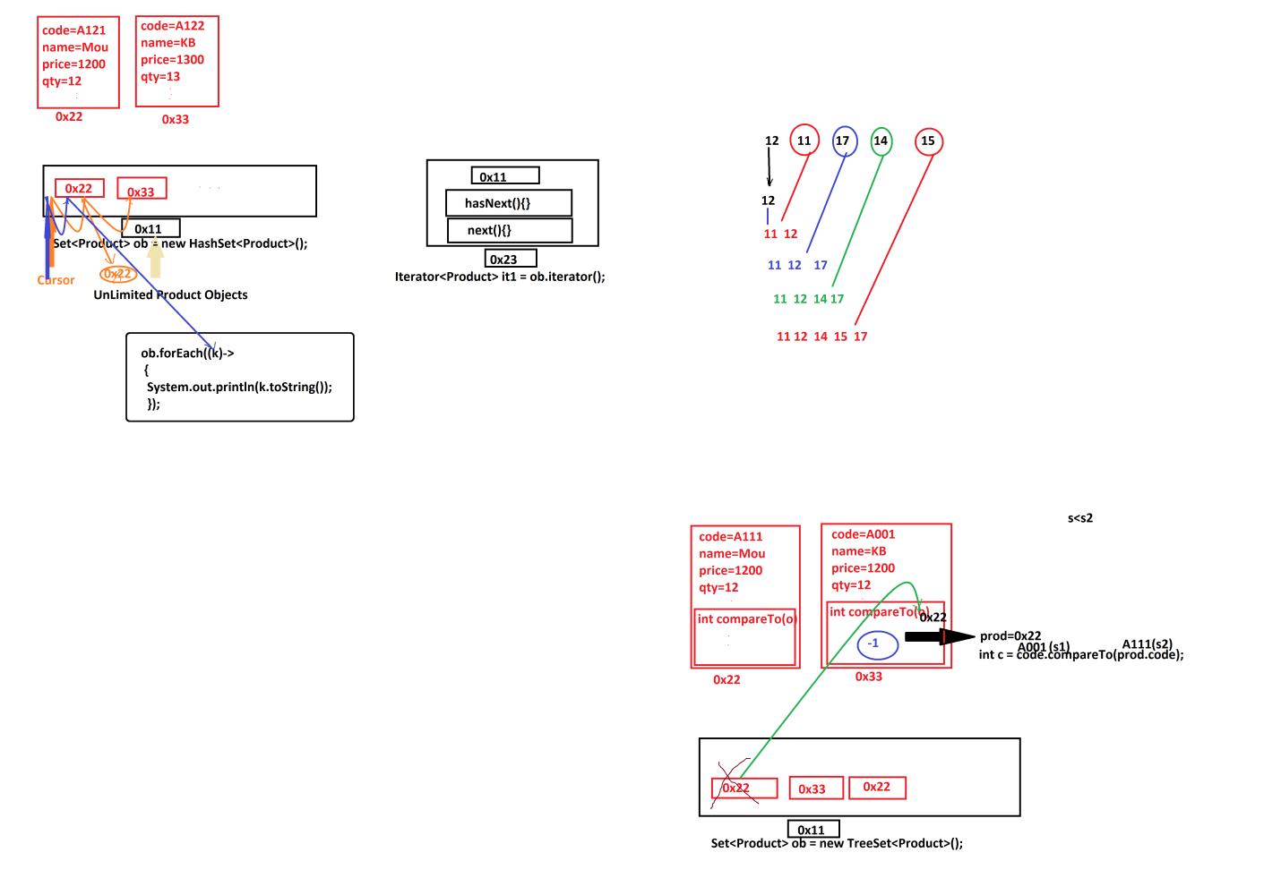

***=============================================================***

***Dt : 26/11/2022***

***Object Oriented Programming Levels:***

***1.Object definition***

***2.Object Creation***

***3.Object Location***

***4.Object Components***

***5.Object Types***

***(i)User Defined Class Objects***

***(ii)String Objects***

***(iii)WrapperClass Objects***

***(iV)Array Objects***

***(v)Collection<E> Objects***

***(vi)Map<K,V> Objects***

***(vii)Enum<E> Objects***

***6.Object Serialization***

***7.Object Collection***

***8.Object Locking***

***9.Object Cloning***

***10.Object Sorting***

***\****

***11.Object holding Database table data(AdvJava)***

***================================================================***

***Note:***

***=>Some methods related to Set<E> and List<E>.***

***SetMethods.java***

***package maccess;***

***import java.util.*;***

***public class SetMethods {***

***@SuppressWarnings("removal")***

***public static void main(String[] args) {***

***HashSet<Integer> hs1 = new HashSet<Integer>();***

***hs1.add(new ~~Integer~~(12));***

***hs1.add(new ~~Integer~~(13));***

***hs1.add(new ~~Integer~~(14));***

***hs1.add(new ~~Integer~~(15));***

***System.out.println("*****hs1****");***

***System.out.println(hs1.toString());***

***HashSet<Integer> hs2 = new HashSet<Integer>();***

***hs2.add(new ~~Integer~~(16));***

***hs2.add(new ~~Integer~~(17));***

***hs2.add(new ~~Integer~~(18));***

***hs2.add(new ~~Integer~~(19));***

***System.out.println("*****hs2****");***

***System.out.println(hs2.toString());***

***System.out.println("****addAll()****");***

***hs1.addAll(hs2);***

***System.out.println(hs1.toString());***

***System.out.println("****removeAll()****");***

***hs1.removeAll(hs2);***

***System.out.println(hs1.toString());***

***HashSet<Integer> hs3 = new HashSet<Integer>();***

***hs3.add(new ~~Integer~~(12));***

***hs3.add(new ~~Integer~~(13));***

***System.out.println("****contains(Object)****)");***

***System.out.println(hs1.contains(new ~~Integer~~(12)));***

***System.out.println("****containsAll(Collection<E>)****)");***

***System.out.println(hs1.containsAll(hs3));***

***HashSet<Integer> hs4 = new HashSet<Integer>();***

***hs4.add(new ~~Integer~~(121));***

***hs4.add(new ~~Integer~~(13));***

***hs4.add(new ~~Integer~~(141));***

***hs4.add(new ~~Integer~~(15));***

***hs1.retainAll(hs4);//Common elements are displayed***

***System.out.println("****retainAll(Collection<E>)*****");***

***System.out.println(hs1);***

***}***

***}***

***ListMethods.java***

***package maccess;***

***import java.util.*;***

***public class ListMethods {***

***@SuppressWarnings("removal")***

***public static void main(String[] args) {***

***ArrayList<Integer> al = new ArrayList<Integer>();***

***al.add(new ~~Integer~~(12));***

***al.add(new ~~Integer~~(13));***

***al.add(new ~~Integer~~(14));***

***al.add(new ~~Integer~~(15));***

***System.out.println(al.toString());***

***System.out.println("****subList(index,index)****");***

***List<Integer> al2 = al.subList(1, 3);***

***al2.forEach((k)->***

***{***

***System.out.print(k.toString()+" ");***

***});***

***}***

***}***

***=================================================================***